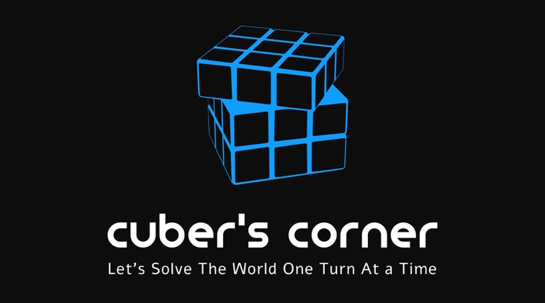

Media Release Form
Participant’s Name:_____________________________________________________________________________ Date of Birth:_______________________________________________________________________________________ Address:____________________________________________________________________________________________ Phone number:_____________________________________________________________________________________ Email:_______________________________________________________________________________________________

I _________________________________________(name), hereby grant permission for my images, videos, and any other media of myself that is taken by representatives of Cuber’s Corner, or that is submitted by myself to Cuber’s Corner, to be used for the purpose of promotion. I hereby grant Cuber’s Corner and its legal representations, assigns, licensees, advertising agencies and all persons or organizations acting with its permission, the unrestricted right to use, re-use, publish, broadcast and copyright my image/sound/still or moving recording and/or voice recording, in all forms of media now or hereafter known and in all manner including electronic media in all formats, in whole or part and or composite representations, including alterations, modifications, derivations and composites thereof, throughout Canada but not limited to, for advertising, promotion, trade or any and all lawful purpose(s).
I waive any right to inspect or approve the finished product that may be created in connection or otherwise to the use to which it may be applied. I acknowledge that (if applicable) the photography/film/video/audio recording sessions and or production was conducted by Cuber’s Corner in a completely proper and highly professional manner, and that I have given my consent freely and willingly and to the above conditions.
I hereby warrant that I have read and understood the release and have the legal authority to execute the release without breach of any prior agreement or applicable law, including but not limited to prior agreements with any other person, company or entity. This agreement shall be binding upon me and my heirs, legal representations and assigns.

Signed:_________________________________________________ Date:_______________________________________
Printed Name:___________________________________________

